Scout Master:
Scout Master Mike Poelzer comes from a large Seattle family. Once a scout himself, he has never actually left his childhood. Having tasted scouting as a youth, and participating in his own son’s cub pack and scout troop, he has been the cornerstone of this troop since 2002.

Mike is fully engaged in making this boy run program flourish. He encourages boys of all backgrounds and abilities to grow in the scouting program.

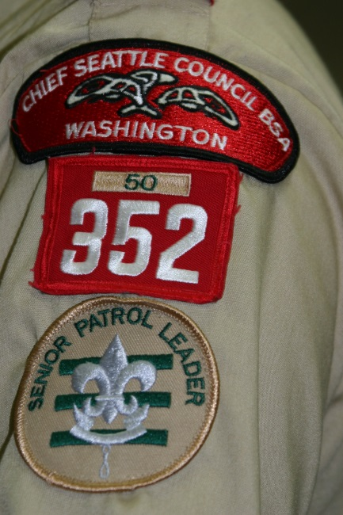

Come see for yourself!
We encourage interested boys and parents to visit our program. All are welcome to drop in on any Monday evening to see if Boy Scout Troop 352 is a good fit for your scout.

A Scout is…

Trustworthy
Loyal
Helpful
Friendly
Courteous
Kind
Obedient
Cheerful
Thrifty
Brave
Clean
Reverent

Boy Scout Troop 352
Established in 1953

Boy run program
Weekly meetings
Monthly outings
Annual activities calendar
Service projects
Cultural diversity
Long history of Eagle Scout achievements

We are a fun and dynamic troop committed to youth leadership development, safety, encouraging the boys to reach Eagle, guided by the Scout Oath and Law.

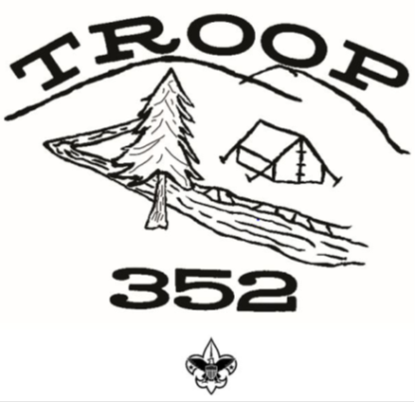

Troop Committee Chairman
(206) 819-6026
Join Today!!
Join Today!!
Youth wishing to join our troop and who meet the eligibility requirements on the Boy Scout Membership Application are welcome to join and will receive a troop 352 Joining Packet.

Requirements:
Boys between the age of 11 and 18 years old, or have completed the 5th grade, or have earned the Arrow of Light are eligible for troop enrollment.

Who:
Boys seeking fun, leadership skills, lifetime friendships, the great outdoors and more!!

What:
Leadership Friendship
Backpacking Cycling
Camping Swimming
Archery Canoeing
Cooking Fishing
First Aid Pioneering
Sports Scout Skills
…and much, much more!

When:
Weekly Meetings
Mondays from 7:00pm to 8:30pm

Where:
Highline United Methodist Church
13015 1st Ave S, Burien, WA, 98168
(Basement Fellowship Hall)

Why:
This troop is boy led and has more fun and activities than most troops! Boys learn lifelong skills, and leadership in a dynamic, fun, environment encouraging the trail to Eagle.

Adult Volunteer Opportunities:
Consider getting involved with a fun and rewarding position within the troop such as:
Troop Committee Chairman
Charter Organization Rep
Secretary
Treasurer
Advancement Chair
Communications Director
Fund Raising Director
Equipment Director
Outdoor/Activities Director
Training Coordinator
Scouting Coordinator
Create your own needed position

Troop Committee contact information:

Troop Committee Chair: Martin Fore (206) 819-6026
Scout Master: Mike Poelzer (206) 618-2008
Asst. Scout Master: Kevin Hall
Charter Representative: Don Anderson
Treasurer: Sue Fore (206) 819-6017
Advancement Chair: Bob Jones
Quartermaster: Dean Dyson
Recruitment Coordinator: Gail James

Visit us at: http://troop352wa.ScoutLander.com

